**Name: Kevin Chacko Abraham**

**Roll No: 13**

**Batch: BATCH B**

**Date: 25-03-2022**

**ADVANCED DATA BASE MANAGEMENT SYSTEM LAB**

**Experiment No.: 1**

**Aim**

To study various DDL commands – CREATE, INSERT

**QUESTION**

Create the following Tables and Insert values.

**Table 1: DEPOSIT**

ACTNO VARCHAR (5) PRIMARY KEY, FIRST LETTER MUST START WITH ‘D’

CNAME VARCHAR (20) FOREIGN KEY REFERENCES CUSTOMER

BNAME VARCHAR (20) FOREGIGN KEY REFERENCES BRANCH

AMOUNT NUMBER (8,2) NOT NULL, CANNOT BE 0

ADATE DATE

**Table 2: BRANCH**

BNAME VARCHAR2(20) PRIMARY KEY

CITY VARCHAR2(30) NOT NULL , any one of NAGPUR, DELHI, BANGALORE, BOMBAY

**Table 3: CUSTOMER**

CNAME VARCHAR (15) PRIMARY KEY

CITY VARCHAR (20) NOT NULL

**Table 4: BORROW**

LOANNO VARCHAR (28) PRIMARY KEY / FIRST LETTER MUST START WITH ‘L’

CNAME VARCHAR (15) FOREIGN KEY REFERENCES CUSTOMER

BNAME VARCHAR2(20) FOREIGN KEY REFERENCES BRANCH

AMOUNT NUMBER(8,2) NOT NULL, CANNOT BE 0

**PROCEDURE**

1. **DATABASE**

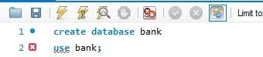

1. **TABLE**

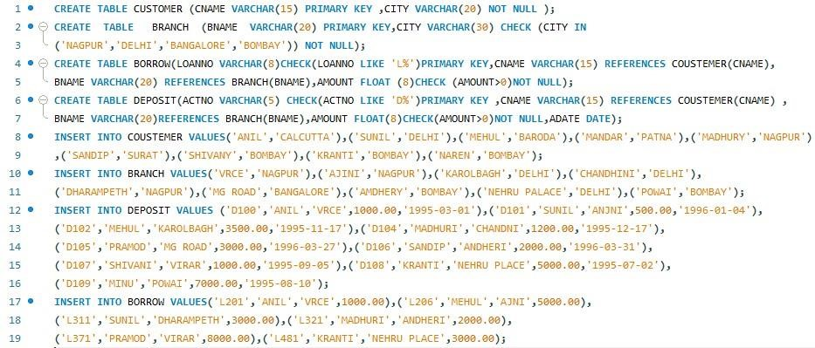

**Output**

1. **TABLE DEPOSIT**

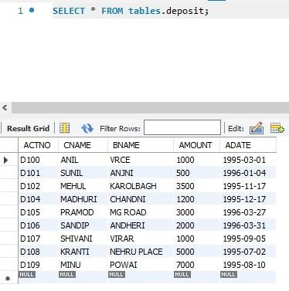

1. **TABLE BRANCH**

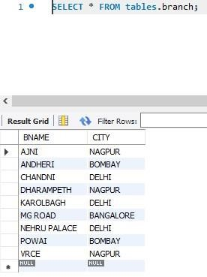

1. **TABLE CUSTOMER**

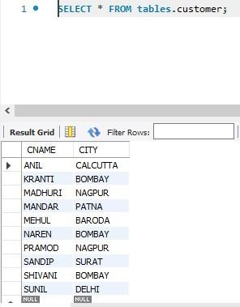

1. **TABLE BORROW**

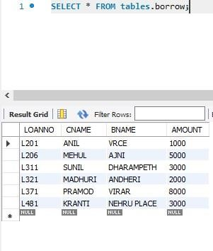

**Name: Kevin Chacko Abraham**

**Roll No:13**

**Batch: BATCH B**

**Date: 08-04-2022**

**ADVANCED DATA BASE MANAGEMENT SYSTEM LAB**

**Experiment No.: 2**

**Aim**

To familiarize with selecting data from single table

**Questions**

1. List all data from table deposite.

2. List all data from borrow.

3. List all data from customer.

4. List all data from branch.

5. Give account no and amount of deposite.

6. Give customer name and account no of depositors.

7. Give name of customers.

8. Give name of branches.

9. Give name of borrows.

10. Give names of customer living in city Nagpur.

11. Give names of depositors having amount greater than 4000.

12. Give account date of Anil.

13. Give name of all branches located in Bombay.

14. Give name of borrower having loan number l205.

15. Give names of depositors having account at VRCE.

16. Give names of all branched located in city Delhi.

17. Give name of the customers who opened account date ‘1-12-96’.

18. Give account no and deposit amount of customers having account opened between

dates  ‘1-12-96’ and ‘1-5-96’.

19. Give name of the city where branch KAROLBAGH is located.

20. Give details of customer ANIL.

**Procedure & Output**

1. Display Deposit: select * from deposit;

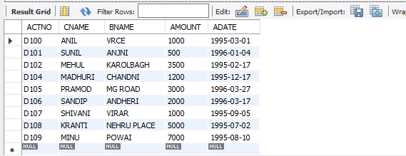

1. Display Borrow: select * from borrow;

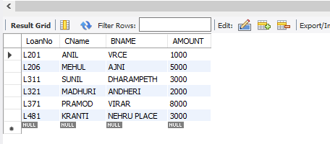

1. Display Customer: select * from customer;

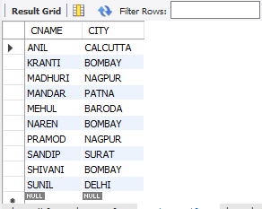

1. Display Branch: select * from branch;

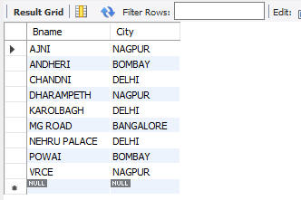

1. SELECT ACTNO,AMOUNT FROM DEPOSIT;

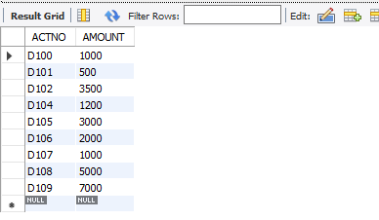

1. SELECT CNAME,ACTNO FROM DEPOSIT;

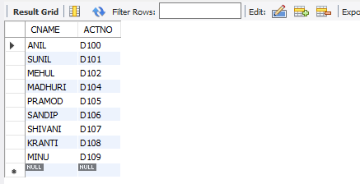

1. SELECT CNAME FROM CUSTOMER;

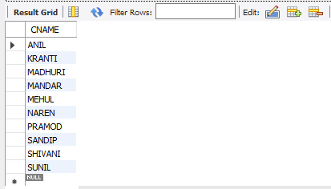

1. SELECT BNAME FROM BRANCH;

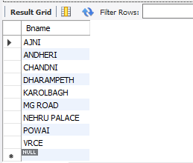

1. SELECT CNAME FROM BORROW;

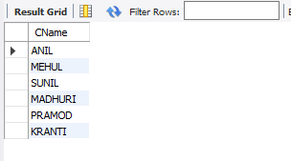

1. SELECT CNAME FROM CUSTOMER WHERE CITY='NAGPUR';

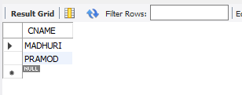

1. SELECT CNAME from DEPOSIT where AMOUNT>4000;

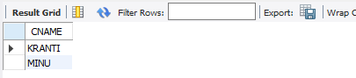

1. SELECT ADATE FROM DEPOSIT where CNAME='ANIL';

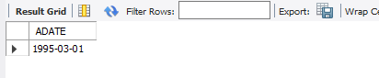

1. SELECT BNAME from BRANCH where CITY='Bombay';

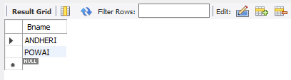

1. SELECT CNAME from BORROW where LOANNO='L205';

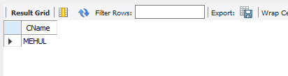

1. SELECT CNAME from DEPOSIT WHERE BNAME='VRCE';

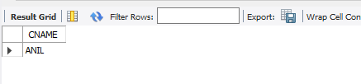

1. SELECT BNAME from BRANCH WHERE CITY='Delhi';

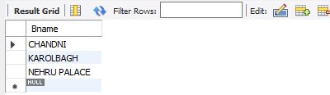

1. SELECT CNAME from DEPOSIT WHERE ADATE='1995-03-1';

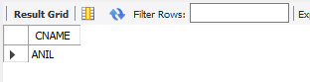

1. SELECT ACTNO,AMOUNT from DEPOSIT WHERE ADATE BETWEEN '1996-12-1'  AND '1996-05-1';

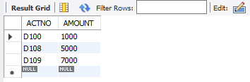

1. SELECT CITY from BRANCH WHERE BNAME='KAROLBAGH';

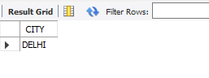

1. SELECT * from customer join borrow on customer.cname=borrow.cname join deposit on deposit.cname=borrow.cname WHERE customer.cname='ANIL';

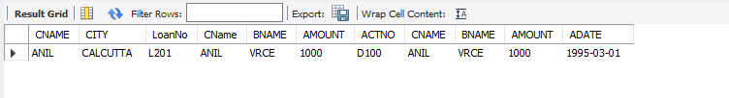

ADVANCED DATA BASE MANAGEMENT SYSTEM LAB

Name : Kevin Chacko Abraham

Roll No: 13

Batch: MCA B

Date: 08 /04/2022

**EXPERIMENT 3**

**AIM**

To familiarize DDL Commands- ALTER,DROP,TRUNCATE,RENAME

**QUESTION**

1.Create a table emp with attributes empno number(4)as primary key, ename char(10), hiredate ,  salary, commission  insert 5 rows of data

2.Modifying the structure of tables

a. Add new columns: sal number (7,2)

b. Dropping a column from a table: sal

c. Modifying existing column: ename varchar2(15)

d. Renaming the tables: emp to emp1

e. truncating the tables: emp1

f. Destroying tables:emp

3.Create a table stud with sname varchar2(20) primary key , rollno number(10) not null,dob  date not null

4.Create a table student as regno number (6), mark number (3) check constraint (mark >=0 and  mark  <=100));

5.Create a table cust with(custid number(6) constraint unique, name char(10)

**PROCEDURE & OUTPUT**

1. CREATE TABLE emp (EMPNO INT (4) PRIMARY KEY, ENAME CHAR (10), HIREDATE DATE, SALARY INT(5),COMMISSION INT(5));

INSERT INTO emp (EMPNO, ENAME, HIREDATE, SALARY, COMMISSION) VALUES (101,'RAMESH','1980-01-17',5000, null), (102,'AJAY','1985-07-05',5000,500),

(103,'RAVI','1981-08-12', 1500, null), (104,'Nikesh','1983-03-03',3000,700),

(105,'Ravi','1985-07-05', 3000, null);

SELECT * FROM emp;

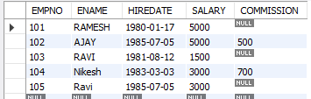

2. a. ALTER TABLE emp ADD sal int;

SELECT * FROM emp;

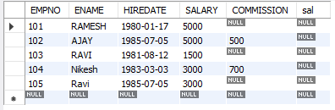

2. b. ALTER TABLE emp DROP COLUMN sal;

SELECT * FROM emp;

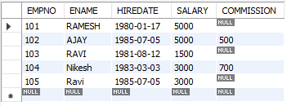

2. c. ALTER TABLE emp MODIFY ename VARCHAR (15);

SELECT * FROM emp;

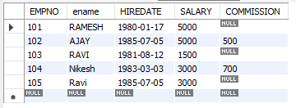

2. d. RENAME table emp to emp1;

SELECT * FROM emp;

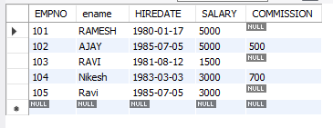

2. e. TRUNCATE TABLE emp1;

SELECT * FROM emp;



2. f. DROP TABLE emp1;

SELECT * FROM emp;



3 .CREATE TABLE stud(sname varchar(20) PRIMARY KEY, rollno int NOT NULL, dob date NOT NULL);

SELECT * FROM stud;



4 .Create table student (regno int, mark int(3) constraint b check (mark >=0 and mark <=100)); SELECT * from STUDENT;



5. CREATE TABLE cust(custid number(6) UNIQUE, name char(10));

select * from cust;



ADVANCED DATABASE MANAGEMENT SYSTEM LAB

Name: Kevin Chacko Abraham

Roll No: 13

Batch: BATCH B

Date: 25-03-2022

**Experiment No.: 4**

**Aim**

To familiarize with aggregate functions

**Questions**

1. List total loan

2. List total deposit

3. List total loan taken from KAROLBAGH branch

4. List total deposit of customers having account date later than 1-Jan-96

5. List total deposit of customers living in city NAGPUR

6. List maximum deposit of customer living in Bombay

7. List total deposit of customer having branch in BOMBAY

8. Count total number of branch cities

9. Count total number of customers cities

10. Give branch names and branch wise deposit

11. Give city wise name and branch wise deposit

12. Give the branch wise loan of customer living in NAGPUR

13. Count total number of customers

14. Count total number of depositors branch wise

15. Give maximum loan from branch VRCE

16.Give the number of customers who are depositors as well as borrowers

**Procedure & Output**

1. SELECT SUM(Amount) FROM borrow;

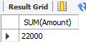

1. SELECT SUM(Amount) FROM deposit;

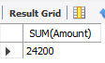

1. SELECT MAX(Amount) FROM borrow WHERE bname ='Karlobhag';

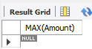

1. SELECT SUM(Amount) from deposit where adate>'1995-03-01';

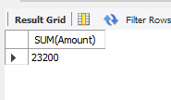

1. SELECT SUM(D1.Amount) FROM deposit D1 , customer C1 WHERE C1.city = 'NAGPUR' AND C1.cname = D1.cname;

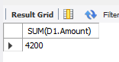

1. SELECT MAX(D1.Amount) FROM deposit D1 , customer C1 WHERE C1.city = 'Bombay' AND C1.cname = D1.cname;

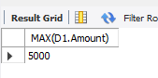

1. SELECT SUM(Amount) from deposit,branch where city='Bombay';

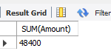

1. SELECT COUNT(DISTINCT(city)) FROM branch ;

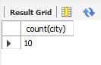

1. SELECT count(city) from customer;

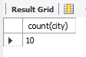

1. SELECT bname , SUM(Amount) FROM deposit GROUP BY bname;

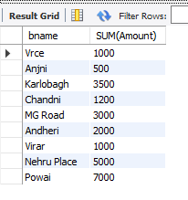

1. SELECT C1.city , SUM(D1.amount) FROM customer C1 , deposit D1 WHERE D1.cname = C1.cname GROUP BY C1.city;

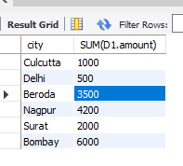

1. SELECT bname , SUM(Amount) FROM borrow,customer WHERE city ='Nagpur' GROUP BY bname;

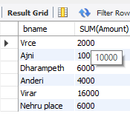

1. SELECT count(cname) from customer;

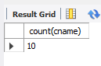

1. select bname, count(*) from deposit, customer where deposit.cname = customer.cname group by bname;

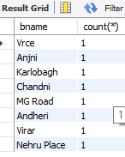

1. SELECT MAX(Amount) FROM borrow WHERE bname ='Vrce';

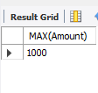

1. select count(distinct(b1.cname)) from borrow b1, deposit d1 where b1.cname in (select cname from deposit);

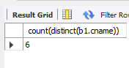

**Name: Kevin Chacko Abraham**

**Roll No: 13**

**Batch: BATCH B**

**Date: 25-03-2022**

ADVANCED DATA BASE MANAGEMENT SYSTEM LAB

**Experiment No.: 5**

**Aim**

To familiarize with set operations

**Questions**

1. List all the customers who are depositors but not borrowers.

2. List all the customers who are both depositors and borrowers

3. List all the depositors having deposit in all the branches where Sunil is having Account

4. List all the customers living in city NAGPUR and having branch city BOMBAY or DELHI

5. List all the depositors living in city NAGPUR

6. List all the depositors living in the city NAGPUR and having branch in city BOMBAY

7. List the branch cities of Anil and Sunil

8. List the customers having deposit greater than 1000 and loan less than 10000.

9. List the cities of depositors having branch VRCE.

10. List the depositors having amount less than 1000 and living in the same city as Anil

11. List all the cities where branches of Anil and Sunil are locate

12. List the amount for the depositors living in the city where Anil is living

**Procedure & Output**

1. SELECT distinct(d1.cname) FROM DEPOSIT d1 where d1.cname not in (SELECT CNAME FROM BORROW);

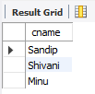

1. select d1.cname from deposit d1 where d1.cname in (select cname from borrow);

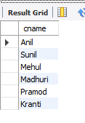

1. SELECT D1.CNAME FROM DEPOSIT D1 WHERE D1.BNAME IN (SELECT D2.BNAME FROM DEPOSIT D2 WHERE D2.CNAME = 'SUNIL' );

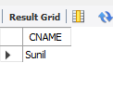

1. SELECT C1.CNAME FROM CUSTOMER C1,DEPOSIT D1, BRANCH B1 WHERE C1.CITY = 'NAGPUR' AND C1.CNAME = D1.CNAME AND D1.BNAME = B1.BNAME AND B1.CITY IN ('BOMBAY','DELHI');

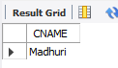

1. SELECT Distinct(CUSTOMER.CNAME) from CUSTOMER,DEPOSIT WHERE City='NAGPUR';

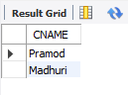

1. SELECT C1.CNAME FROM CUSTOMER C1,DEPOSIT D1, BRANCH B1 WHERE C1.CITY = 'NAGPUR' AND C1.CNAME = D1.CNAME AND D1.BNAME = B1.BNAME AND B1.CITY IN ('BOMBAY');

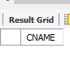

1. SELECT B1.CITY FROM DEPOSIT D1, BRANCH B1 WHERE D1.BNAME = B1.BNAME AND D1.CNAME IN ('SUNIL' ,'ANIL');

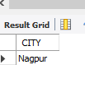

1. SELECT DISTINCT D1.CNAME FROM deposit D1, borrow B1 WHERE D1.AMOUNT>1000 AND B1.AMOUNT<10000;

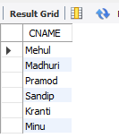

1. SELECT B1.CITY FROM deposit D1, branch B1 WHERE D1.BNAME=B1.BNAME AND B1.BNAME='VRCE';

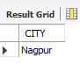

1. SELECT D1.CNAME FROM deposit D1, customer C1 WHERE AMOUNT<1000 AND C1.CITY=(C1.CNAME='ANIL');

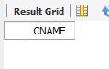

1. SELECT D1.CNAME FROM DEPOSIT D1,CUSTOMER C1 , CUSTOMER C2 WHERE C1.CITY = C2.CITY AND C2.CNAME = 'ANIL' AND C1.CNAME = D1.CNAME AND D1.AMOUNT < 1000;

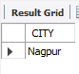

1. SELECT B1.CITY FROM BRANCH B1 WHERE B1.BNAME IN (SELECT D1.BNAME FROM DEPOSIT D1 WHERE D1.CNAME IN ('ANIL','SUNIL'));

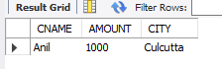

**Name: Kevin Chacko Abraham**

**Roll No: 13**

**Batch: BATCH B**

**Date: 06-05-2022**

ADVANCED DATA BASE MAMAGEMENT SYSTEM LAB

**Experiment No.: 6**

**Aim**

To familiarize with join or cartesian product

**Questions**

1. Give name of customers having living city BOMBAY and branch city NAGPUR

2. Give names of customers having the same living city as their branch city

3.Give names of customers who are borrowers as well as depositors and having city

NAGPUR.

4.Give names of borrowers having deposit amount greater than 1000 and loan amount greater

than 2000.

5.Give names of depositors having the same branch as the branch of Sunil

6.Give names of borrowers having loan amount greater than the loan amount of Pramod

7.Give the name of the customer living in the city where branch of depositor Sunil is located.

8.Give branch city and living city of Pramod

9.Give branch city of Sunil and branch city of Anil

10.Give the living city of Anil and the living city of Sunil

**Procedure & Output**

**1.** SELECT D1.CNAME FROM DEPOSIT D1,CUSTOMER C1,BRANCH B1 WHERE

C1.CITY = 'BOMBAY' AND B1.CITY = 'Bombay' AND D1.CNAME = C1.CNAME AND D1.BNAME = B1.BNAME;

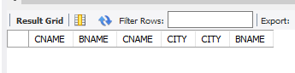

1. SELECT distinct(customer.CNAME), BRANCH.CITY FROM BRANCH, customer

WHERE BRANCH.city = customer.city;

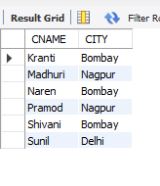

1. SELECT C1.CNAME FROM CUSTOMER C1,DEPOSIT D1,BORROW B1 WHERE

C1.CITY='NAGPUR' AND C1.CNAME=D1.CNAME AND D1.CNAME = B1.CNAME;

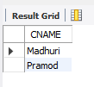

1. SELECT BR1.CNAME, BR1.AMOUNT, D1.CNAME, D1.AMOUNT FROM

BORROW BR1,DEPOSIT D1 WHERE D1.CNAME = BR1.CNAME AND D1.AMOUNT >

1000 AND BR1.AMOUNT > 2000;

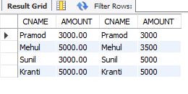

1. SELECT D1.CNAME FROM DEPOSIT D1 WHERE D1.BNAME IN (SELECT

D2.BNAME FROM DEPOSIT D2 WHERE D2.CNAME = 'SUNIL');

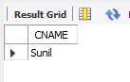

1. SELECT BR1.CNAME,BR1.AMOUNT FROM BORROW BR1 WHERE

BR1.AMOUNT > ALL (SELECT BR2.AMOUNT FROM BORROW BR2 WHERE

BR2.CNAME = 'PRAMOD');

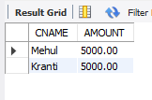

1. SELECT C.CNAME FROM CUSTOMER C WHERE C.CITY IN (SELECT B.CITY

FROM BRANCH B WHERE B.BNAME IN (SELECT D.BNAME FROM DEPOSIT D

WHERE D.CNAME='SUNIL'));

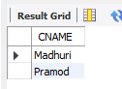

1. SELECT B1.CITY , C1.CITY FROM BRANCH B1,CUSTOMER C1, DEPOSIT D1

WHERE C1.CNAME = 'PRAMOD' AND C1.CNAME = D1.CNAME AND D1.BNAME =

B1.BNAME;

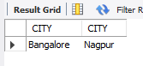

1. SELECT B1.CITY FROM DEPOSIT D1, BRANCH B1 WHERE D1.BNAME =

B1.BNAME AND D1.CNAME IN ('SUNIL' ,'ANIL');

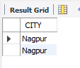

1. SELECT C1.CNAME, C1.CITY FROM CUSTOMER C1 WHERE C1.CNAME =

'ANIL' OR C1.CNAME = 'SUNIL';

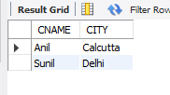

**Name: Kevin Chacko Abraham**

**Roll No: 13**

**Batch: BATCH B**

**Date: 06-05-2022**

ADVANCED DATA BASE MAMAGEMENT SYSTEM LAB

**Experiment No.: 7**

**Aim**

To familiarize with Group by and Having clause

**Questions**

1.List the branches having sum of deposit more than 5000.

2.List the branches having sum of deposit more than 500 and located in city BOMBAY

3.List the names of customers having deposited in the branches where the average deposit is

more than 5000.

4.List the names of customers having maximum deposit

5.List the name of branch having highest number of depositors?

6.Count the number of depositors living in NAGPUR.

7.Give names of customers in VRCE branch having more deposite than any other customer in

same branch

8.Give the names of branch where number of depositors is more than 5

9.Give the names of cities in which the maximum number of branches are located

10.Count the number of customers living in the city where branch is located

**Procedure & Output**

**1.** SELECT D.BNAME FROM DEPOSIT D, BRANCH B WHERE

D.BNAME=B.BNAME AND B.CITY='BOMBAY' GROUP BY D.BNAME HAVING

SUM(D.AMOUNT)>5000;

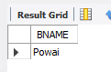

**2.** SELECT D.BNAME FROM DEPOSIT D, BRANCH B WHERE

D.BNAME=B.BNAME GROUP BY D.BNAME HAVING SUM(D.AMOUNT)>5000;

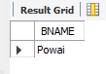

**3**. select CNAME from deposit where AMOUNT=(select AVG(Amount) from DEPOSIT

GROUP BY BNAME having AVG(Amount)>5000);

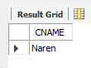

**4.** SELECT MAX(AMOUNT),CNAME FROM deposit;

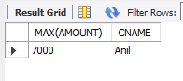

1. SELECT D1.BNAME FROM DEPOSIT D1 GROUP BY D1.BNAME HAVING

COUNT(D1.CNAME) >= ALL (SELECT COUNT(D2.CNAME) FROM DEPOSIT D2

GROUP BY D2.BNAME);

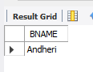

**6**. select count(deposit.cname)from deposit,CUSTOMER where

CUSTOMER.CITY='nagpur';

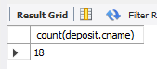

**7.** Select CNAME from deposit where BNAME='VRCE' and amount=(select

max(AMOUNT) from deposit where BNAME='VRCE');

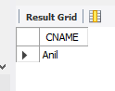

**8.** SELECT BNAME from deposit GROUP BY BNAME HAVING

COUNT(BNAME)>5;

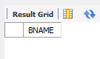

**9.** select C.CNAME ,count(B.BNAME) from CUSTOMER C inner join Branch B on

C.CNAME=B.BNAME group by C.Cname order by count(B.BName) DESC;

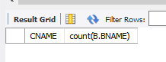

**10**. select count(b1.bname) From deposit d1 , borrow b1 , customer c1 Where

c1.cname=d1.cname and d1.cname=b1.cname and c1.city in (select city from customer);

